Company Dash startup and dashboard
Document 31 of the Nexora learning guides
Source snapshot 14 October 2026 at 06:41 UTC
Run the local maintenance dashboard and understand how it connects to Nexora.

Recognise the screen and its scope
Open http://127.0.0.1:8000/#overview. Company Dash uses loopback port 8000 and hash navigation. Open its separate repository in VS Code before Ctrl+P. The source library uses company-dash as a project label, not a Nexora folder.
This guide covers Local startup; Overview and navigation; Configuration diagnostics; Local request token; Separate repository and data.
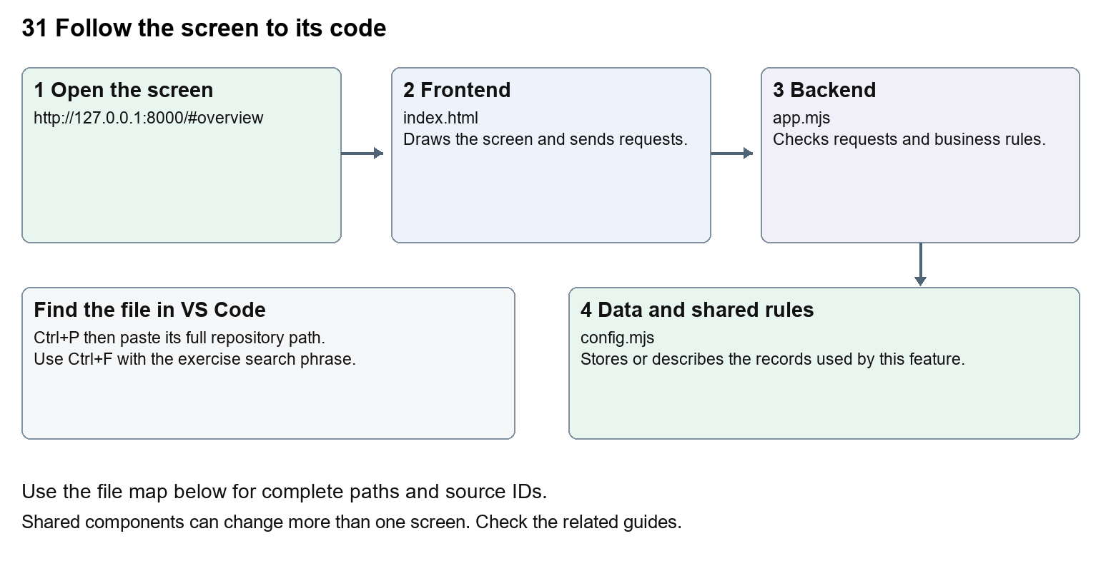
The diagram shows the file roles. The full paths below are what you paste into Ctrl+P.

Find the files in VS Code
Role | File and source ID | What it does
Screen | S0698 index.html | Main UI or route for this topic
Server | S0701 app.mjs | Endpoints or server rules
Data | S0704 config.mjs | Data shape or persistence structure

Screen S0698
public/index.html
Server S0701
server/app.mjs
Data S0704
server/config.mjs
Use the HTML source buttons for full files. Word shows labelled extracts; individual Markdown guides contain complete primary files.

Follow the request and the records
1. Open the Company Dash folder in its own VS Code window and run node server/main.mjs.
2. The Node server serves public/index.html, app.js and styles.css on loopback port 8000.
3. The browser gets a local request token from /api/session and sends X-Command-Token with API requests.
4. GET /api/state returns repository, tasks, runs and provider status.
5. The browser renders the selected view; the server keeps task history in its own SQLite database.

Read the code with an explanation
Company Dash is a separate Node.js application, not a Nexora API module. Its public folder is the frontend; server contains the backend. It needs Node 24 or newer for built-in SQLite and has no frontend build or npm dependencies. Run it from its own folder; opening index.html as a file will not provide its API. config.example.json shows safe defaults; local configuration and data stay private. The dashboard can inspect the Nexora checkout without becoming a runtime dependency of CRM, Portal or CMS.
Source reference S0698 company-dash/public/index.html
Extract from source line 8. A fragment from a long line is shown without the rest of that line.
0008 <nav aria-label="Main navigation">

index.html supplies markup and app.js renders browser views. Follow api() to the server route handler.
Source reference S0701 company-dash/server/app.mjs
Extract from source line 23. A fragment from a long line is shown without the rest of that line.
0023 export function createApp(config) {

The browser api() helper sends a method and local request token. app.mjs checks the route and calls the relevant service. Follow that call to understand SQL writes, process execution and filesystem changes.
Source reference S0704 company-dash/server/config.mjs
Selected opening lines with their original numbers. The complete file is in the HTML source library.
0001 import fs from 'node:fs';
0002 import path from 'node:path';
0003 import { fileURLToPath } from 'node:url';
0004 import { resolveCodexPath } from './codex-path.mjs';
0006 export const root = path.resolve(path.dirname(fileURLToPath(import.meta.url)), '..');
0007 const local = path.join(root, 'config.local.json');

store.mjs defines SQLite history tables. catalog.mjs and config.mjs define configuration; repository.mjs records fingerprints. Trace each key into its service before assuming it is a stored table.

Make or trace your first change
1. Press Ctrl+P and open public/index.html.
2. Press Ctrl+F and search for Work board<span. In this snapshot it appears at line 10.
3. Change the sidebar wording only, keeping the href, data-view and span intact. Refresh Company Dash and confirm the same work view opens. Restore the text after practising.
4. Replace only Work board<span with Work requests<span in that intended location. Keep quotes, tags, JSON keys and routes intact.
5. Save with Ctrl+S. Inspect Problems and the local screen. Review the diff and restore the original text when you finish practising.
Extract from source line 10. A fragment from a long line is shown without the rest of that line.
0010 <a href="#work" data-view="work"><span class="nav-icon">▤</span>Work board<span id="work-count" class="nav-count">0</span></a>

These exercises have not been applied to the application. Their search phrases are verified against the captured source. Line numbers can move; the phrase and file path are your main navigation aids.

Check a change and diagnose problems
Confirm the original screen still loads, the changed words appear in the intended place, and another screen using the same component still behaves correctly. If an action fails, inspect the browser Network response, the relevant helper and server validation message. Use the common error table at the beginning of the manual. Reload on a version conflict instead of removing the version check.
A syntax error after a text edit usually means a quote, brace or closing tag changed. Compare your diff with the original. An unchanged browser result can mean the wrong port, a saved published configuration overriding a default, or a running API that has not reloaded.

Understand the current limits
The dashboard is local and single-user. Its request token and Host/Origin checks are not public multi-user authentication. Documentation capture does not start the dashboard, run an agent or change task history.

Continue learning
Related guides 02 Nexora platform setup and VS Code, 32 Company Dash repository and source viewer, 33 Company Dash tasks agents and handoffs, 36 Company Dash history backups and settings.

